Meeting Minutes
- Polygons make shape all the same for the 5V
- If I cant find a waz to easily connect the right 5V inverter edge connector pin to the rest, just have that empty and disconnect in schematics – maybe have another test point for 5V spare
- 2 more caps for 5V layer
- AND Gate – try the pin swapping
- GND connections for everything
- BOM consolidation
  - JLC part number
    - Resistors – resistance, accuracy
    - Caps – capacitance, voltage, dielectric

HOW DO YOU ROUTE THE POWER TO THE INDIVIDUAL LEVLES?????

Quesionts:
- How to route the power to the individual levels
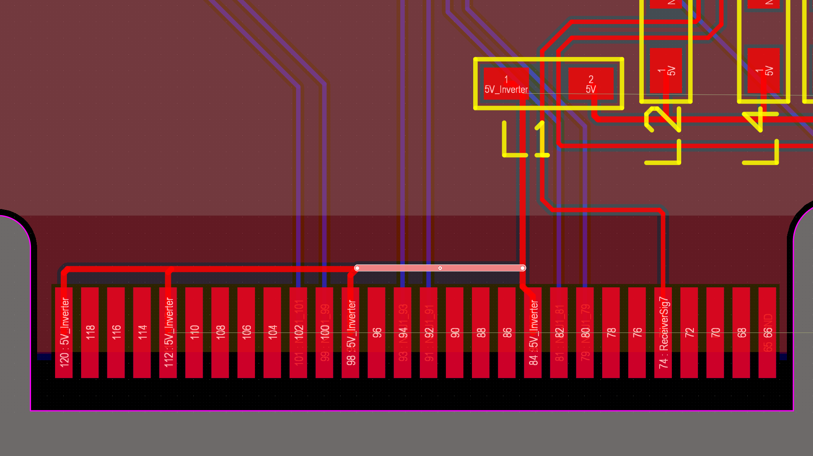 instead of this can I just connect everything down to the VCC layer with vias??
If I cant find a waz to easily connect the right 5V inverter edge connector pin to the rest, just have that empty and disconnect in schematics – maybe have another test point for 5V spare
Pull the 5V VCC layer polygon also down like the others
- Powersupply + GND both have to be 0.2mm right?

Questions about routing
- Is it okay to route all the connections from this end of the resistor?
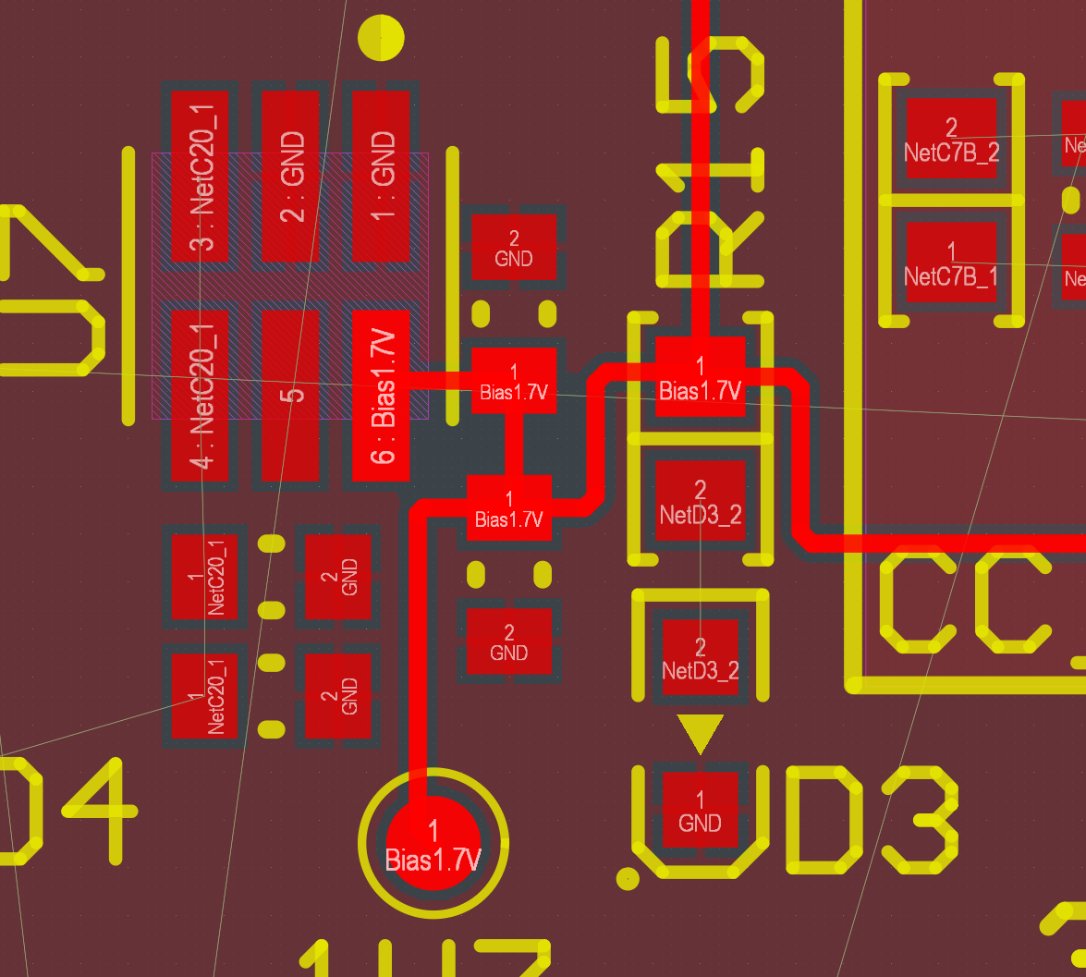This is the resistor for the Diode

- For the feedback to the op amp, there is a difference between this and going around right?
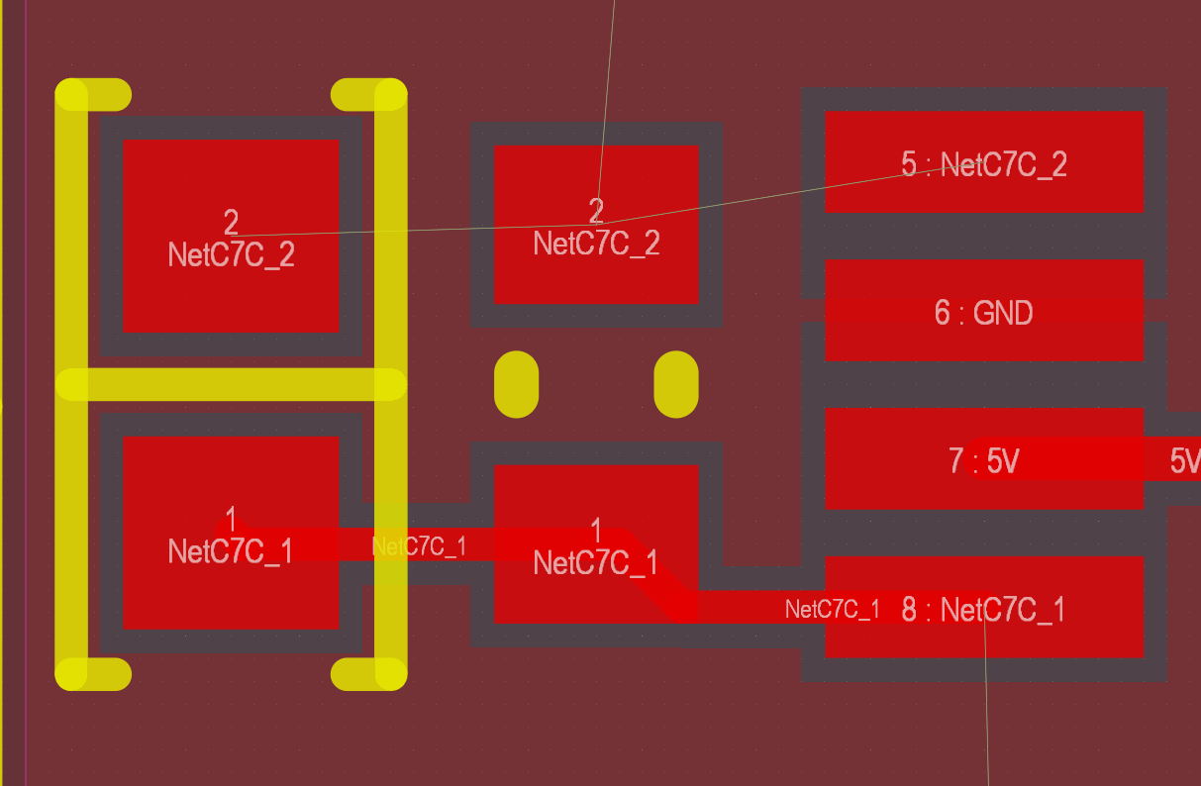

- Tracks on top of orientation points okay?
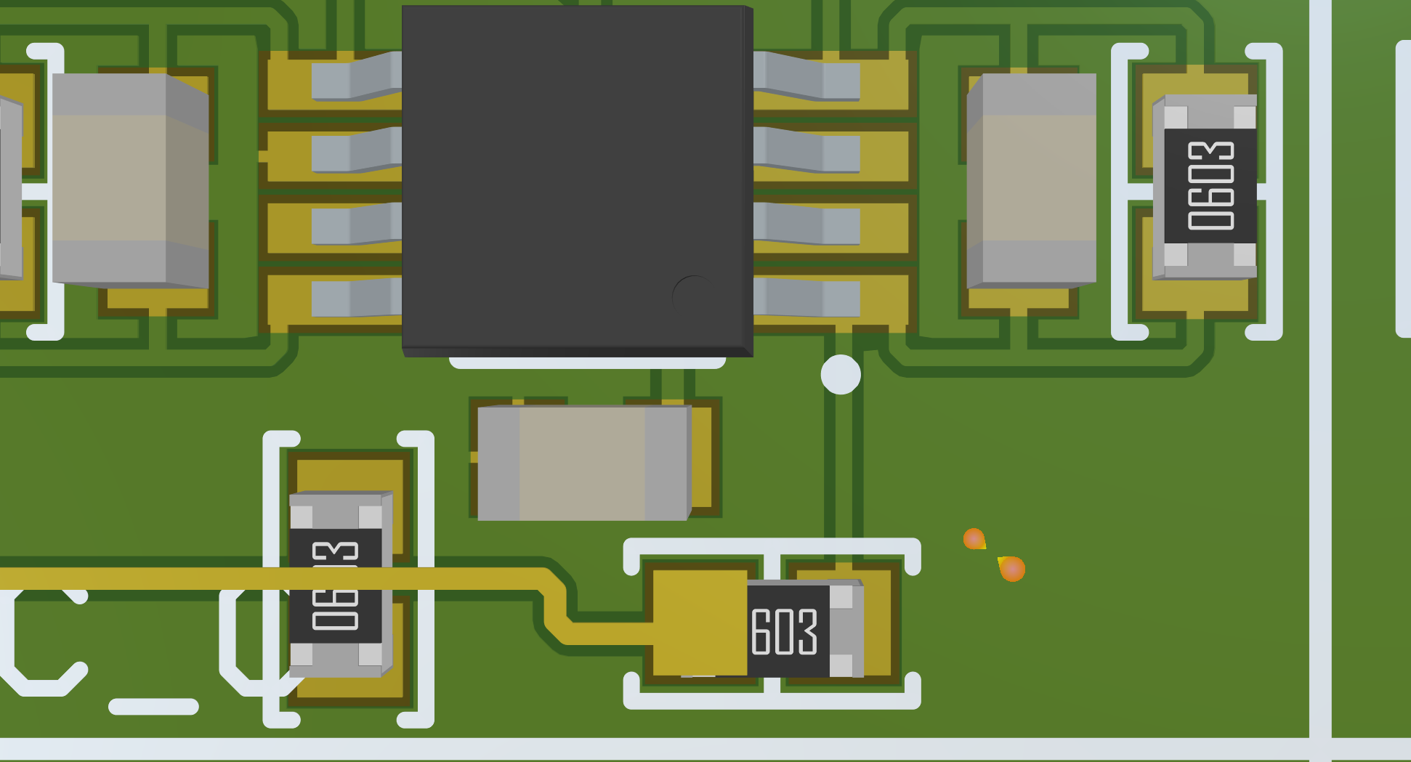
Question about pathway – Signal RxTxA
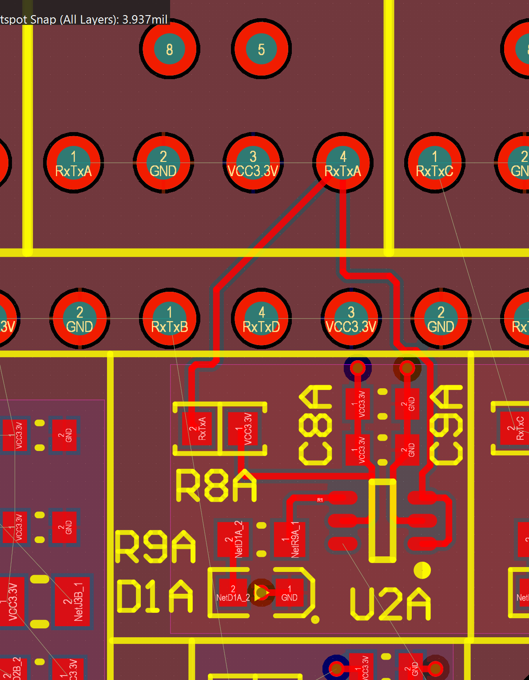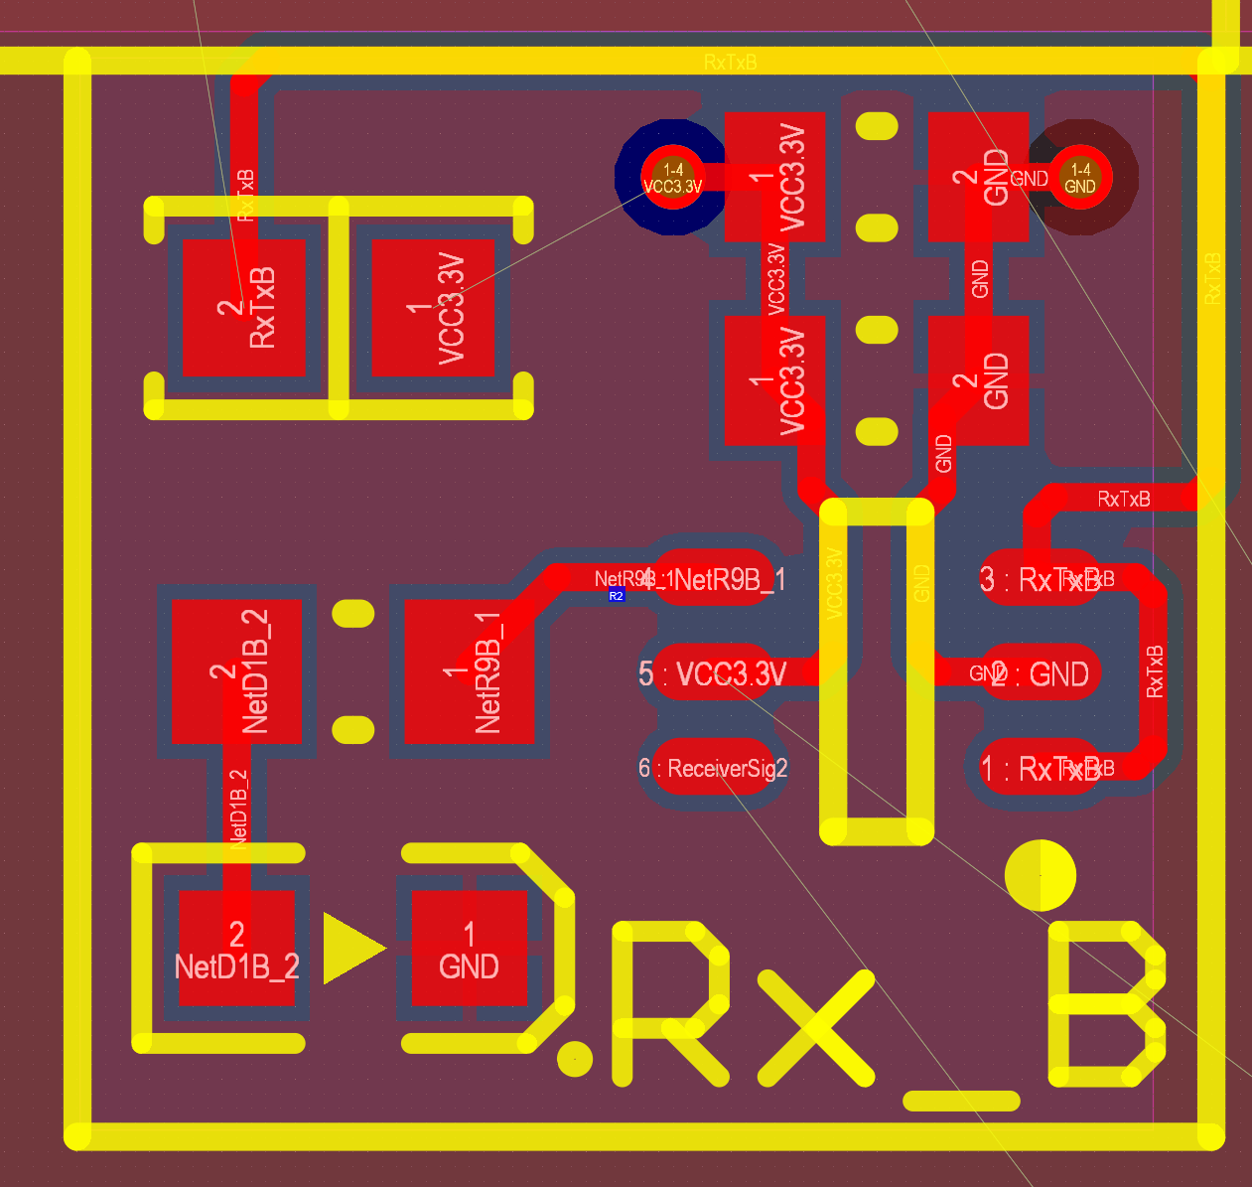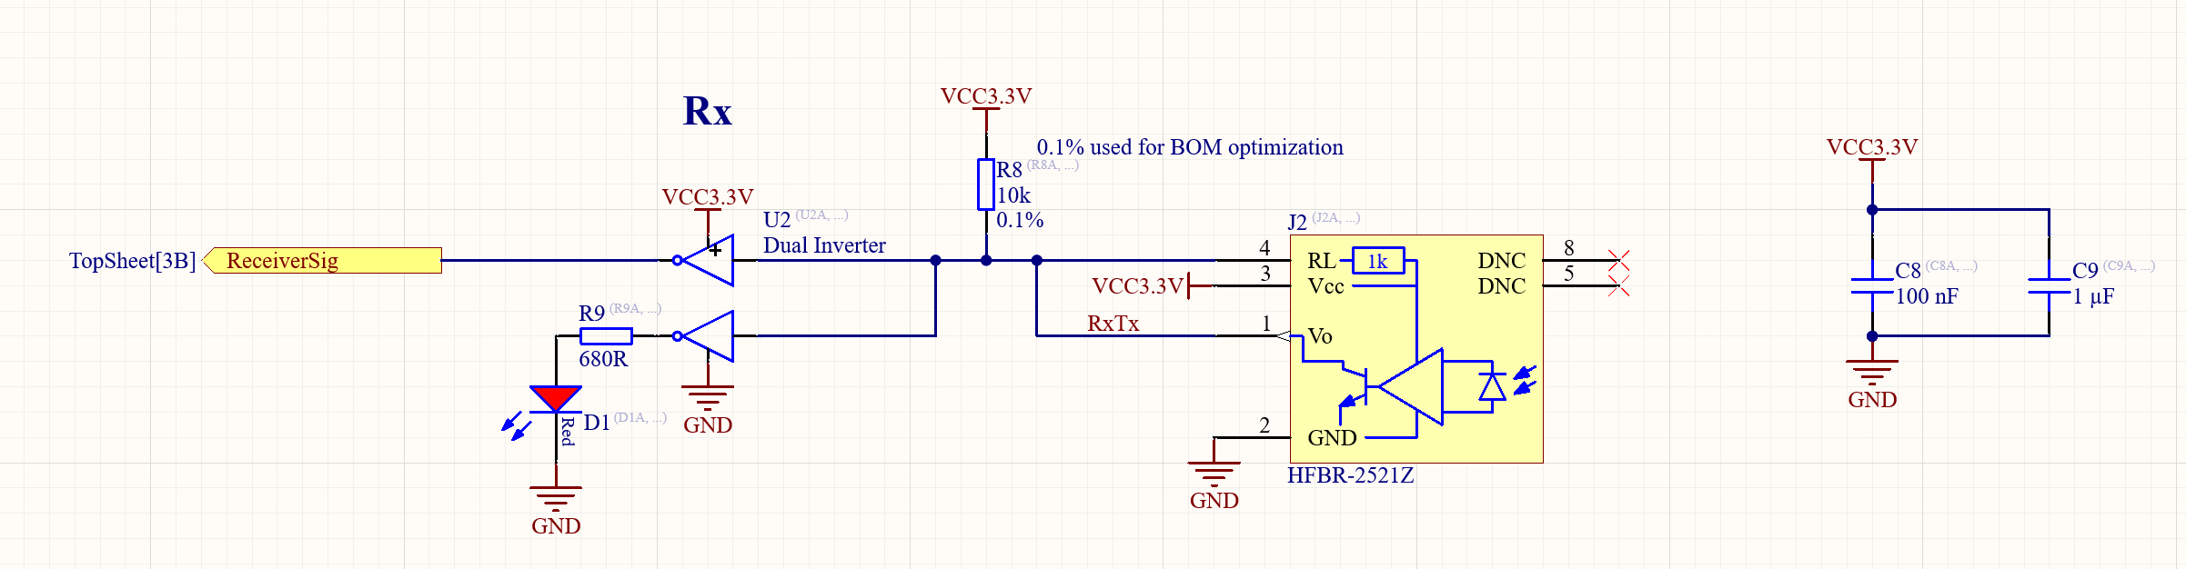

For Receivers and Transmitters:
- I placed the 100nF closer to the dual inverter than the 1uF capacitor
- Also the decoupling capacitors are not connected to the actual transmitter at all (receivers do not have ha direct 3.3V supply as far as I am aware)
Think About:
- Return current path in the GND layer
  - Where is the current returning to lol
- konzentriertheit hypothese
- current pathways in electric circuits

